**PROGRAM 3**

**SUPPLIER DATABASE**

**Consider the following schema:**

**SUPPLIERS (sid: integer, sname: string, address: string)**

**PARTS (pid: integer, pname: string, color: string)**

**CATALOG (sid: integer, pid: integer, cost: real)**

use Supriya;

create table suppliers

(

s_id int(5),

sname varchar(20),

city varchar(20),

primary key (s_id));

desc suppliers;

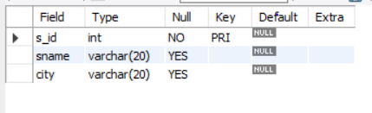

use Supriya;

create table parts

(

pid int(10),

pname varchar(20),

color varchar(20),

primary key(pid));

desc parts;

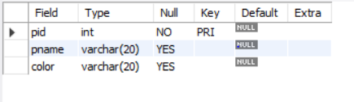

use Supriya;

create table catalog

(

s_id int(10),

pid int(10),

cost float(10),

primary key(pid,s_id),

foreign key(s_id)references suppliers(s_id),

foreign key(pid)references parts(pid));

desc catalog;

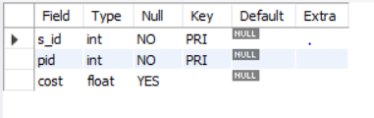

use Supriya;

insert into suppliers values(1,'Reliance','Shrinagar');

insert into suppliers values(2,'RNS','Bangalore');

insert into suppliers values(3,'Acme_Widget','Hubli');

insert into suppliers values(4,'Tata','Dharwad');

insert into suppliers values(5,'Vipro','Bangalore');

select * from suppliers;

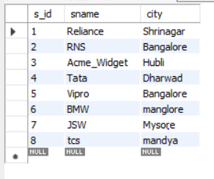

use Supriya;

insert into parts values(1,'break','black');

insert into parts values(2,'engine','brown');

insert into parts values(3,'steering','grey');

insert into parts values(4,'seat','red');

insert into parts values(5,'headlight','red');

insert into parts values(6,'seat','black');

select * from parts;

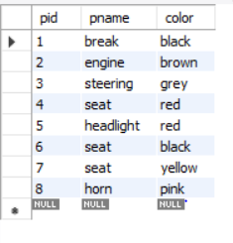

use Supriya;

desc catalog;

insert into catalog values(1,1,'1000.0');

insert into catalog values(2,2,'1500.25');

insert into catalog values(3,3,'2000.50');

insert into catalog values(4,4,'2000.50');

insert into catalog values(5,5,'3000.25');

select * from catalog;

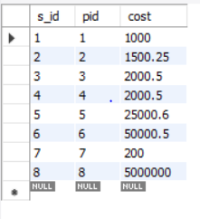

**i)Find the pnames of parts for which there is some supplier.**

use Supriya;

SELECT DISTINCT P.pname FROM parts P, catalog C WHERE P.pid = C.pid;

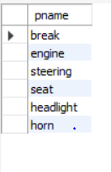

**ii)Find the snames of suppliers who supply every part.**

select s.sname

from suppliers s

where not exists(

select p.pid from parts p where not exists(select c.s_id from catalog c where c.s_id=s.s_id));

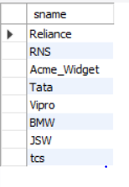

**iii)Find the snames of suppliers who supply every yellow part.**

select s.sname

from suppliers s

where not exists(select p.pid from parts p where p.color='yellow' and not exists(select c.s_id from catalog c

where c.s_id=s.s_id and c.pid=p.pid));

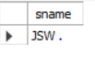

**iv. Find the pnames of parts supplied by Acme Widget Suppliers and by no one else.**

select p.pname

from parts p,catalog c,suppliers s

where p.pid=c.pid and

c.s_id=s.s_id and

s.sname='RNS' and not exists(select * from catalog ca,suppliers su where p.pid=ca.pid and ca.s_id=su.s_id and su.sname<>'RNS');

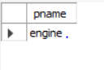

**v.Find the sids of suppliers who charge more for some part than the average cost of that part (averaged over all the suppliers who supply that part).**

select distinct c.s_id

from catalog c

where c.cost>(select avg(ca.cost) from catalog ca,catalog c where ca.pid=c.pid);

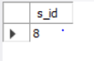

**vi. For each part, find the sname of the supplier who charges the most for that part.**

SELECT P.pid, S.sname

FROM Parts P, Suppliers S, Catalog C

WHERE C.pid = P.pid

AND C.sid = S.sid

AND C.cost = (SELECT MAX (C1.cost)

FROM Catalog C1

WHERE C1.pid = P.pid);

**vii. Find the sids of suppliers who supply only red parts**

select s.s_id from suppliers s where exists(

select c.s_id from catalog c,parts p where p.color='red' and p.pid=c.pid and c.s_id=s.s_id);

